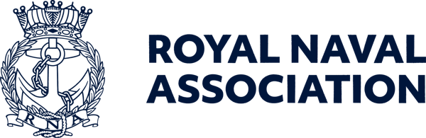

Semaphore Short Friday 15 May 2026

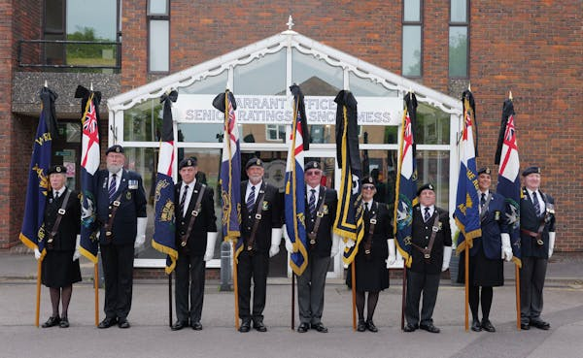

Keeping the standard hight – competitors at the National Standard Bearers competition line up at HMS Collingwood

Immaculately turned out with an eye for detail – and that was just the judges...
The National Standard Bearers competition was hosted by HMS Collingwood in Fareham (and Lee-on-the-Solent and Stubbington Branch) last weekend, and windy conditions ensured the participants had to be at the top of their game.
After a training session on Friday, the competition itself took place on Saturday, as a result of which the RNA's new National Standard Bearer is S/M Martyn Evans, of Paddock Wood Branch (Area 2).
Second place went to S/M Richard Shenton, of Worthing Branch (Area 3), who becomes Martyn's official deputy. Richard also won the Bob Coburn Memorial Trophy for his "indefatigable commitment to RNA standard bearing."
The Novices Shield was won by S/M Lee 'Fred' Perry, of Plymouth Branch (Area 4),while the Asspciation of Wrens Shield was won by S/M Chris Walker.
For more on the copmpetition, and additional images, see https://www.royal-naval-association.co.uk/new-national-standard-bearer-appointed-at-royal-naval-association-championship, while a full report will appear in the June edition of the Semaphore Circular, out on Friday 5 June.

  It will only take you a few minutes to complete the RNA 2026 membership survey, which will enable us to understand all members’ views on the Association and its activities.
  And for one lucky entrant, drawn at random, there will be a £100 Amazon gift voucher for their trouble.
  Completing the survey will help us to deliver more of what members want and need – and if you could all add your email addresses, this would enable us to communicate more effectively with members.
  To take part in the survey please use this link:
  https://forms.office.com/e/wbauj6qJmm
  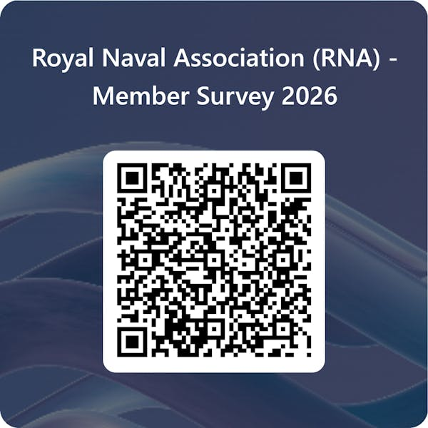

Top jobs up for grabs

Two top positions at the RNA are up for grabs, but you will need to get your skates on as the closing dates for both roles fall later this month.
First up is THE top job – Chief Executive Officer of the RNA (also known to shipmates as the General Secretary).
Bill Oliphant is off to pastures new, so we are looking for someone to take up the baton and lead the membership of over 25,000 through an exciting period of development and beyond.
The salary is around £75,000, depending on the candidate, and the closing date for applications is 22 May, with interviews expected to be conducted in the week commencing 1 June.
For full details of the role and a person spec see https://www.royal-naval-association.co.uk/were-recruiting-chief-executive-officer-general-secretary
The other post being advertised is for the RNA's Communications Lead, supporting the RNRMC's Director of Marketing and Communications in the delivery of the RNA's Communications, Marketing and Promotions plan, playing a pivotal and instrumental role in the day-to-day preparation, management, and execution of the RNA’s communications both internally and externally.
Working as part of RNRMC's Communications team, the job has a salary of up to £33,500, depending on experience, and the closing date for applications is 26 May.
Initial interviews will be held on a rolling basis during the advertising period and RNRMC reserves the right to close the vacancy early and make an appointment at any stage of the application process.
For further details see https://www.royal-naval-association.co.uk/were-recruiting-rna-communications-lead

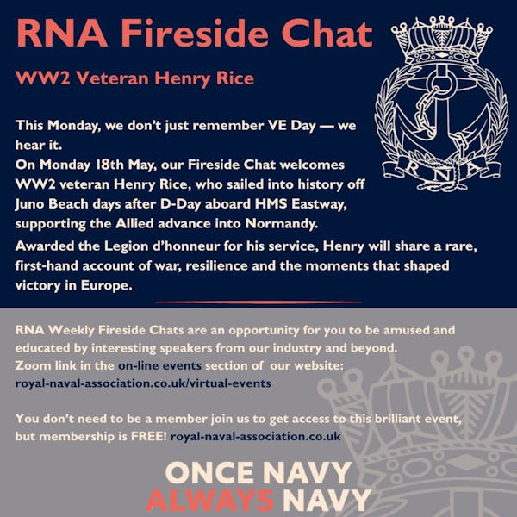

Last call for Welsh veterans

This is your last chance to apply for or nominate someone who you feel is worthy of consideration for the Welsh Veterans Awards.
The applications window closes next Friday (22 May), so if you have a shipmate in mind, go to https://veteransawards.co.uk/welsh-veterans-awards/ for full details of the categories and criteria by which entrants are judged.
The applications process for the Northern Irish Veterans Awards is also open (see https://www.veteransawardsireland.com/northern-ireland-veterans-awards/ for more details) while the English Veterans Awards will be opening for applicatiuons on 1 June – see https://veteransawards.co.uk/english-veterans-awards/#top

  Tea time at Number 10
  Royal Naval Veterans were invited to attend a special VE Day 81 tea party at Number 10 Downing Street.
  And the Royal Naval Association played its part in marking the occasion by supporting World War 2 veterans at the afternoon event at the heart of government, in a moving tribute to their service and sacrifice.
  Former Wrens Dorothy Walsh and Betty Withers, along with former sailor Ken Arkell, all met Prime Minister Sir Keir Starmer at this very special event – and also bumped into the official Number 10 cat Larry, as seen right.
  For more pictures and a fuller report see https://www.royal-naval-association.co.uk/a-nation-remembers-royal-naval-veterans-attend-ve-day-81-tea-at-number-10
  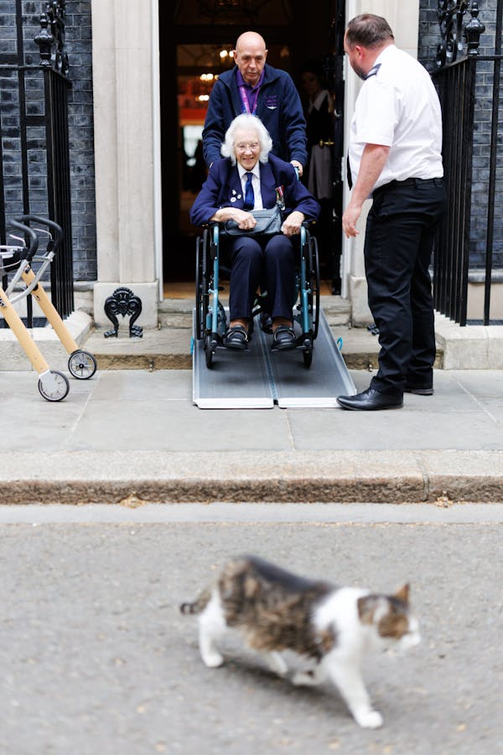

Conference notes

It’s not too late to nominate your Branch delegate to Conference. The relevant form is available in recent editions of the Semaphore Circular, which can be reached through the RNA website at https://www.royal-naval-association.co.uk/category/semaphore-circular
Documentation for the 2026 AGM was emailed out to Branches and Delegates on Friday 1 May and should be discussed at Branch meetings; if you are yet to receive this email, please contact ams@rnassoc.org.

We plan to livestream this year's AGM from the Lowry in Salford, commencing at 0930 on Saturday 13 June. Please note that this is the first time that we have attempted this and it is very much a trial. Also note that this will be a one-way audio/visual livestream only and there will be no options to ask questions or vote on motions.
We must reinforce the fact that this is a trial, so please don’t be frustrated or disappointed if our plans are scuppered!
We of course hope that it will be successful and a platform to build on for future AGMs but please bear with us as we may encounter teething difficulties and issues that are out of our control. Further information, including the platform and log in details to follow.

Going places with your RNA ID card

Just a quick reminder to shipmates that the Bee Network, which runs the transport system in Greater Manchester, has confirmed that free transport will be available for RNA members attending the National Conference in Salford next month.
Shipmates will be able to use trams and buses from Friday 12 June to Sunday 14 June – but only on production of their RNA ID card, so make sure you have it with you when you travel to Salford.
BZ to Salford City Council, City Mayor Paul Dennett, Mayoral staff, Transport for Greater Manchester and the Bee Network team – and to our shipmates in the North-West who are organising the weekend.

 |  |  |  |  |  |  |  |  |  |  | 

